Brian Kiaer

CPE301 – SPRING 2018

Midterm Project

**DO NOT REMOVE THIS PAGE DURING SUBMISSION:**

The student understands that all required components should be submitted in complete for grading of this assignment.

|  |  |  |  |
| --- | --- | --- | --- |
| **NO** | **SUBMISSION ITEM** | **COMPLETED (Y/N)** | **MARKS**  **(/MAX)** |
| 1 | COMPONENTS LIST AND CONNECTION BLOCK DIAGRAM w/ PINS |  |  |
| 2. | INITIAL CODE OF TASK 1/A |  |  |
| 3. | INCREMENTAL / DIFFERENTIAL CODE OF TASK 2/B |  |  |
| 3. | INCREMENTAL / DIFFERENTIAL CODE OF TASK 3/C |  |  |
| 3. | INCREMENTAL / DIFFERENTIAL CODE OF TASK 4/D |  |  |
| 3. | INCREMENTAL / DIFFERENTIAL CODE OF TASK 5/E |  |  |
| 4. | SCHEMATICS |  |  |
| 5. | SCREENSHOTS OF EACH TASK OUTPUT |  |  |
| 5. | SCREENSHOT OF EACH DEMO |  |  |
| 6. | VIDEO LINKS OF EACH DEMO |  |  |
| 7. | GOOGLECODE LINK OF THE DA |  |  |
|  |  |  |  |
|  |  |  |  |

1. **COMPONENTS LIST AND CONNECTION BLOCK DIAGRAM w/ PINS**

Components used:

* ESP8266-01 Module Chip
* FTDI 5V Basic Breakout Chip
* ATMega328P Xplained Mini
* LM34 Temperature Sensor
* Breadboard
* 5V & 3.3V Fixed Power Supply

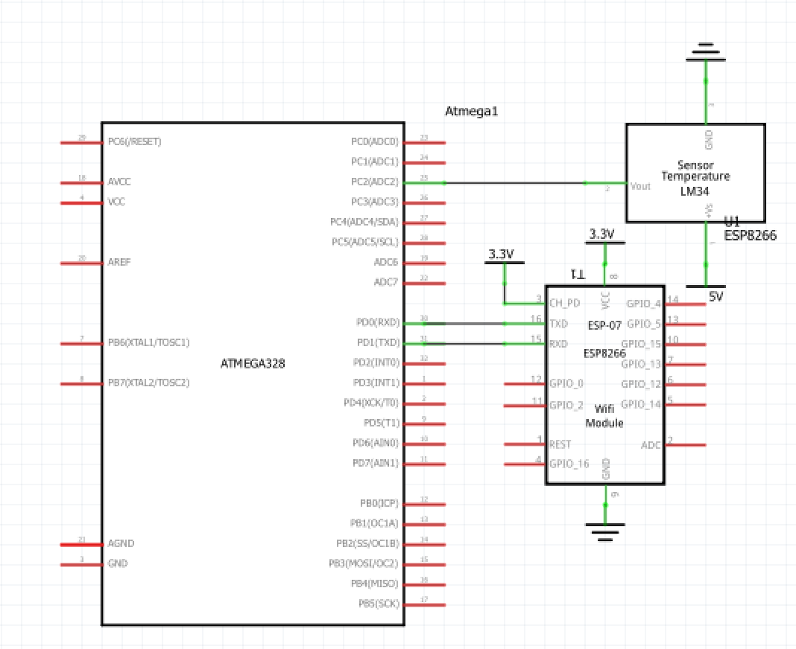

1. **INITIAL/DEVELOPED CODE OF TASK 1/A**

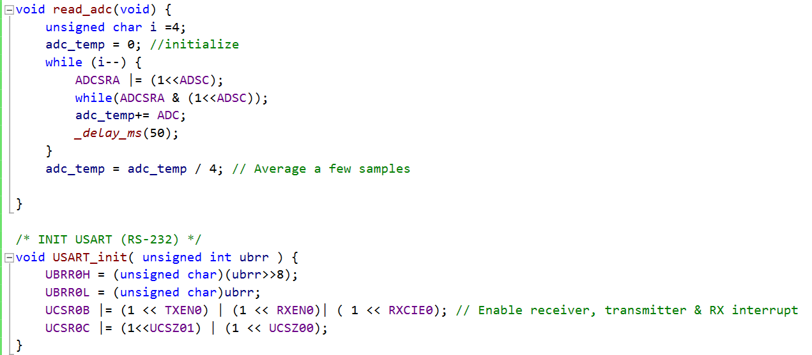

Above is for task 1 where I have to establish a connection with the ATMega328P to read from the LM34 Temperature Sensor. This code is showing the read_adc function which is responsible for reading the values from the LM34 chip and transmitting it to the rest of the code.

1. **MODIFIED CODE OF TASK 2/A from TASK 1/A**

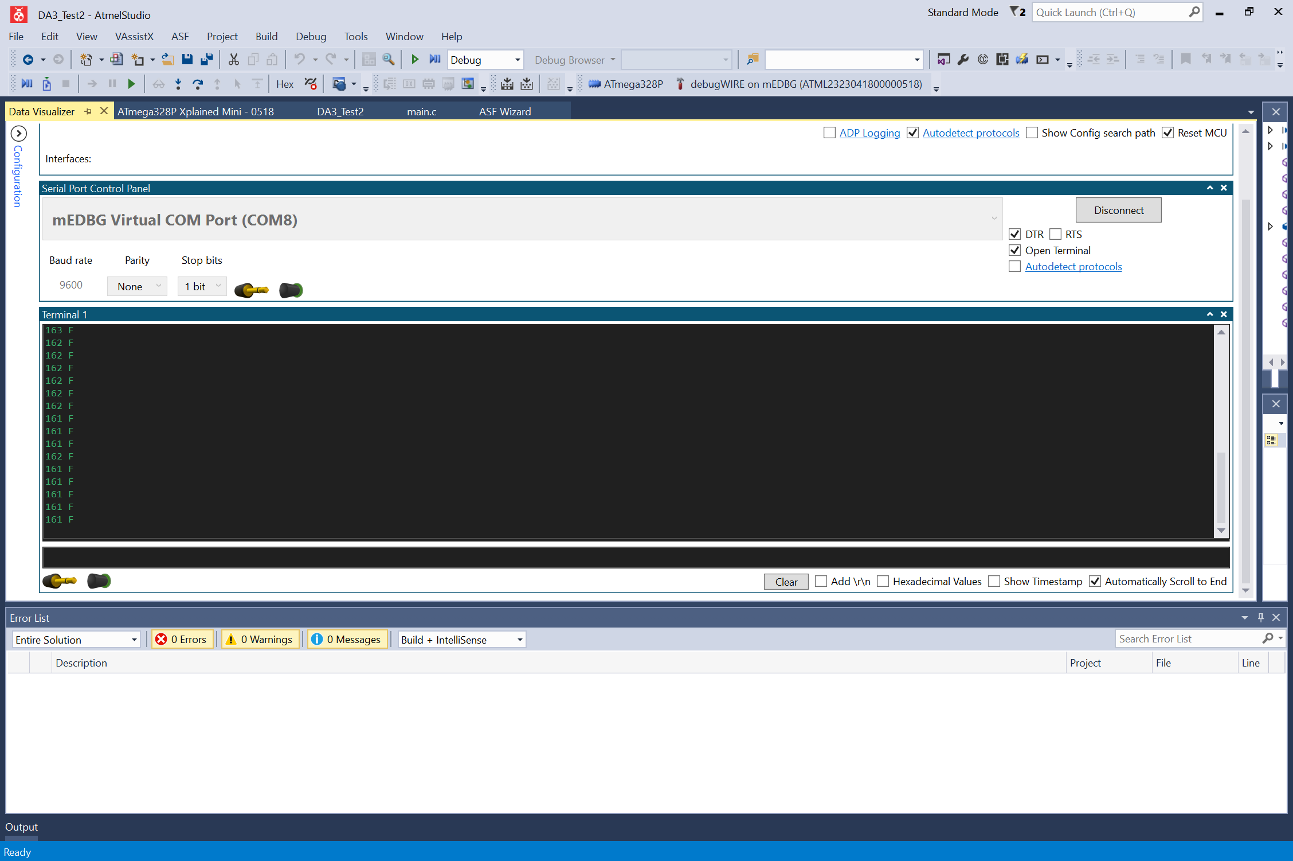

Above is the output from the UART of the ATMega328P Xplained Mini. Above it is displaying the temperature sensor values, this screenshot is displaying the temperature when I am holding the LM34 Chip thus making the temperature higher and then letting go to eventually cool down the chip to a stable temperature.

1. **FIRMWARE FOR ESP8266 MODULE**

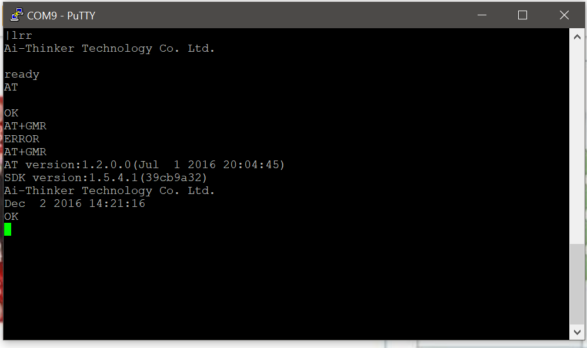

Here we see the firmware of the ESP8266-01 Module out of the box. The AT Version was 1.2.0.0 and the SDK version was 1.5.4.1

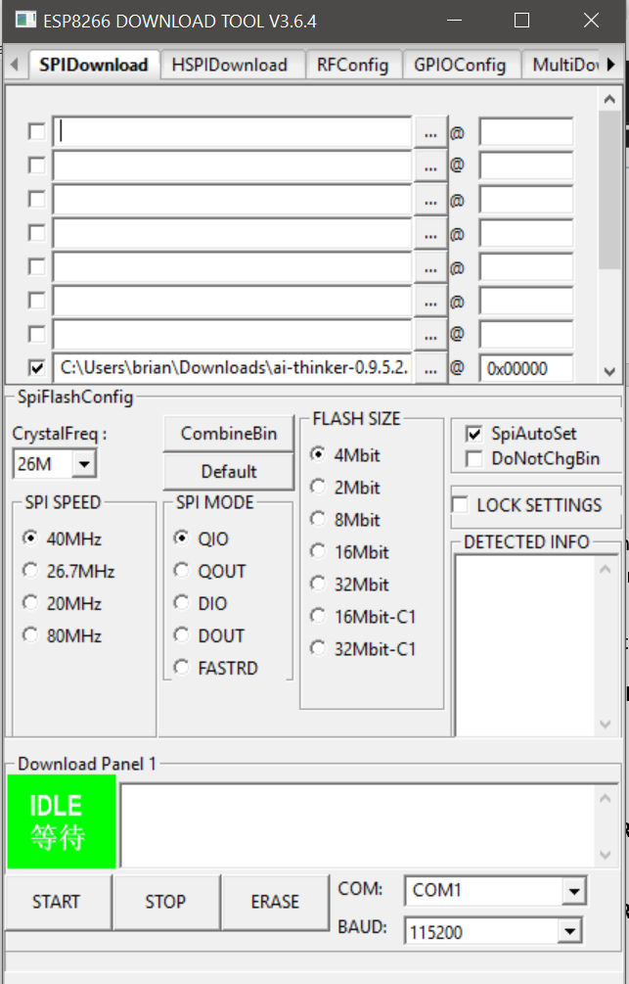

I used the ESP8266 DOWNLOAD TOOL that was provided by the ESPRESSIF website. I manually entered different .bin files to the respective addresses that were provided in the github account provided by the ESPRESSIF website again.

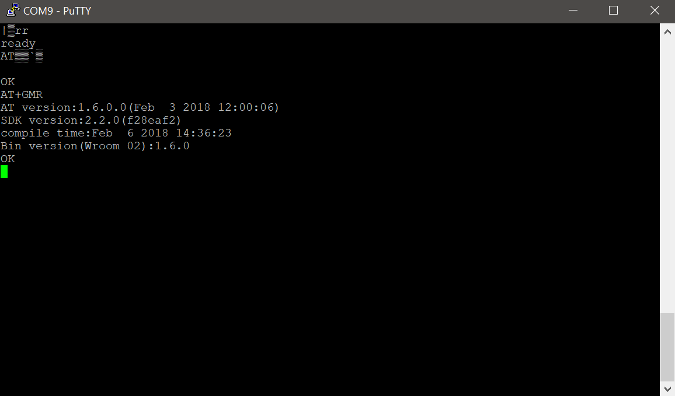

After inputting the specific .bin files and addresses the AT Firmware has been updated after checking via AT Commands -> AT -> AT+GMR. Now the AT Version is 1.6.0.0 and the SDK Version is 2.2.0.

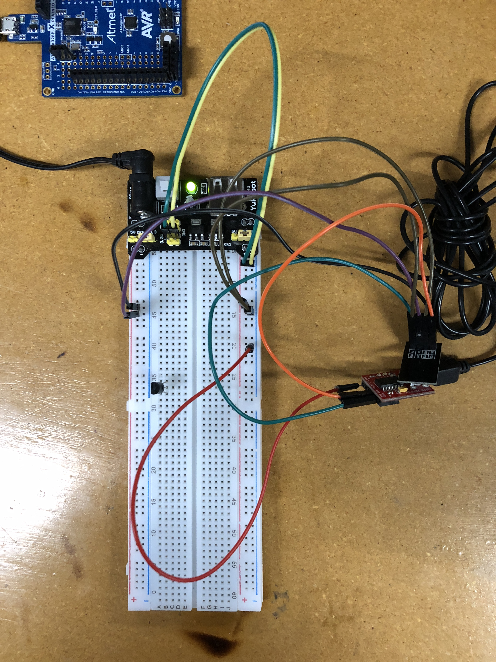

The setup of the board above is what was used to update the AT Firmware of the ESP8266 Module. The ESP8266 Module is connected to a VCC of 3.3V and the RX and TX is connected to the TX and RX, respectively on the FTDI CHIP.

1. **TASK 4 – THINGSPEAK ACCOUNT**

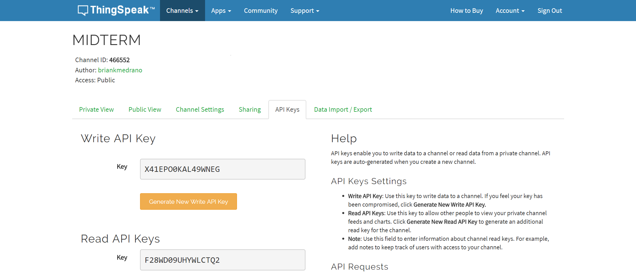

I created a thingspeak account and made a channel called Midterm. The field that I created in the channel correlates with “Temperature”.

1. **SEND DATA TO ESP8266 USING AT+COMMANDS TASK 5**

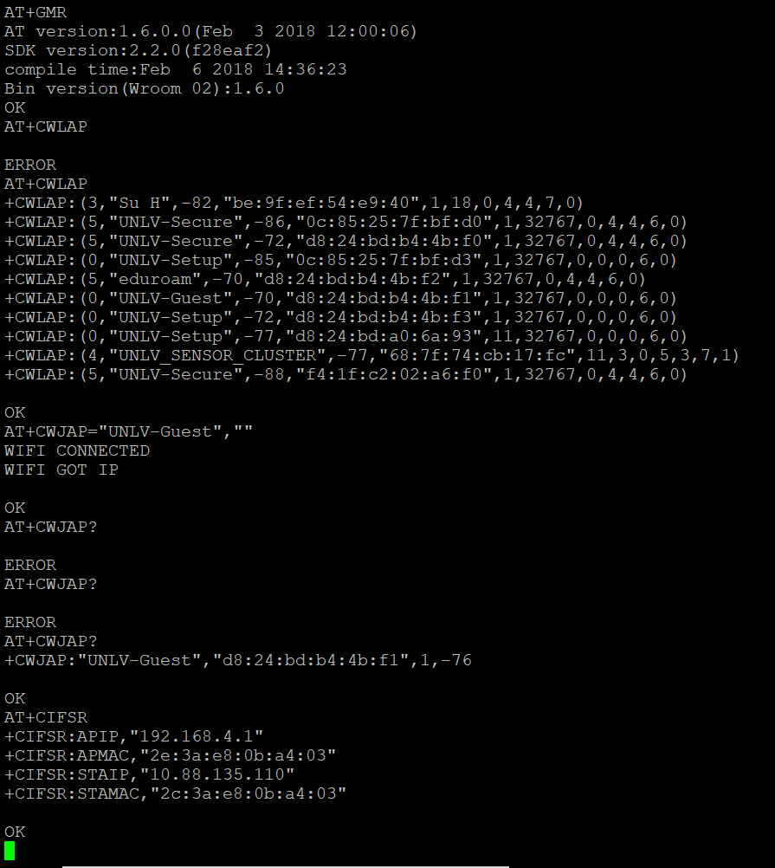

First, I wanted to check that the ESP8266 chip would connect to WiFi. I was able to connect the device to the UNLV-Guest WiFi without a password.

1. **TASK 6 OUTPUT TO THINGSPEAK**

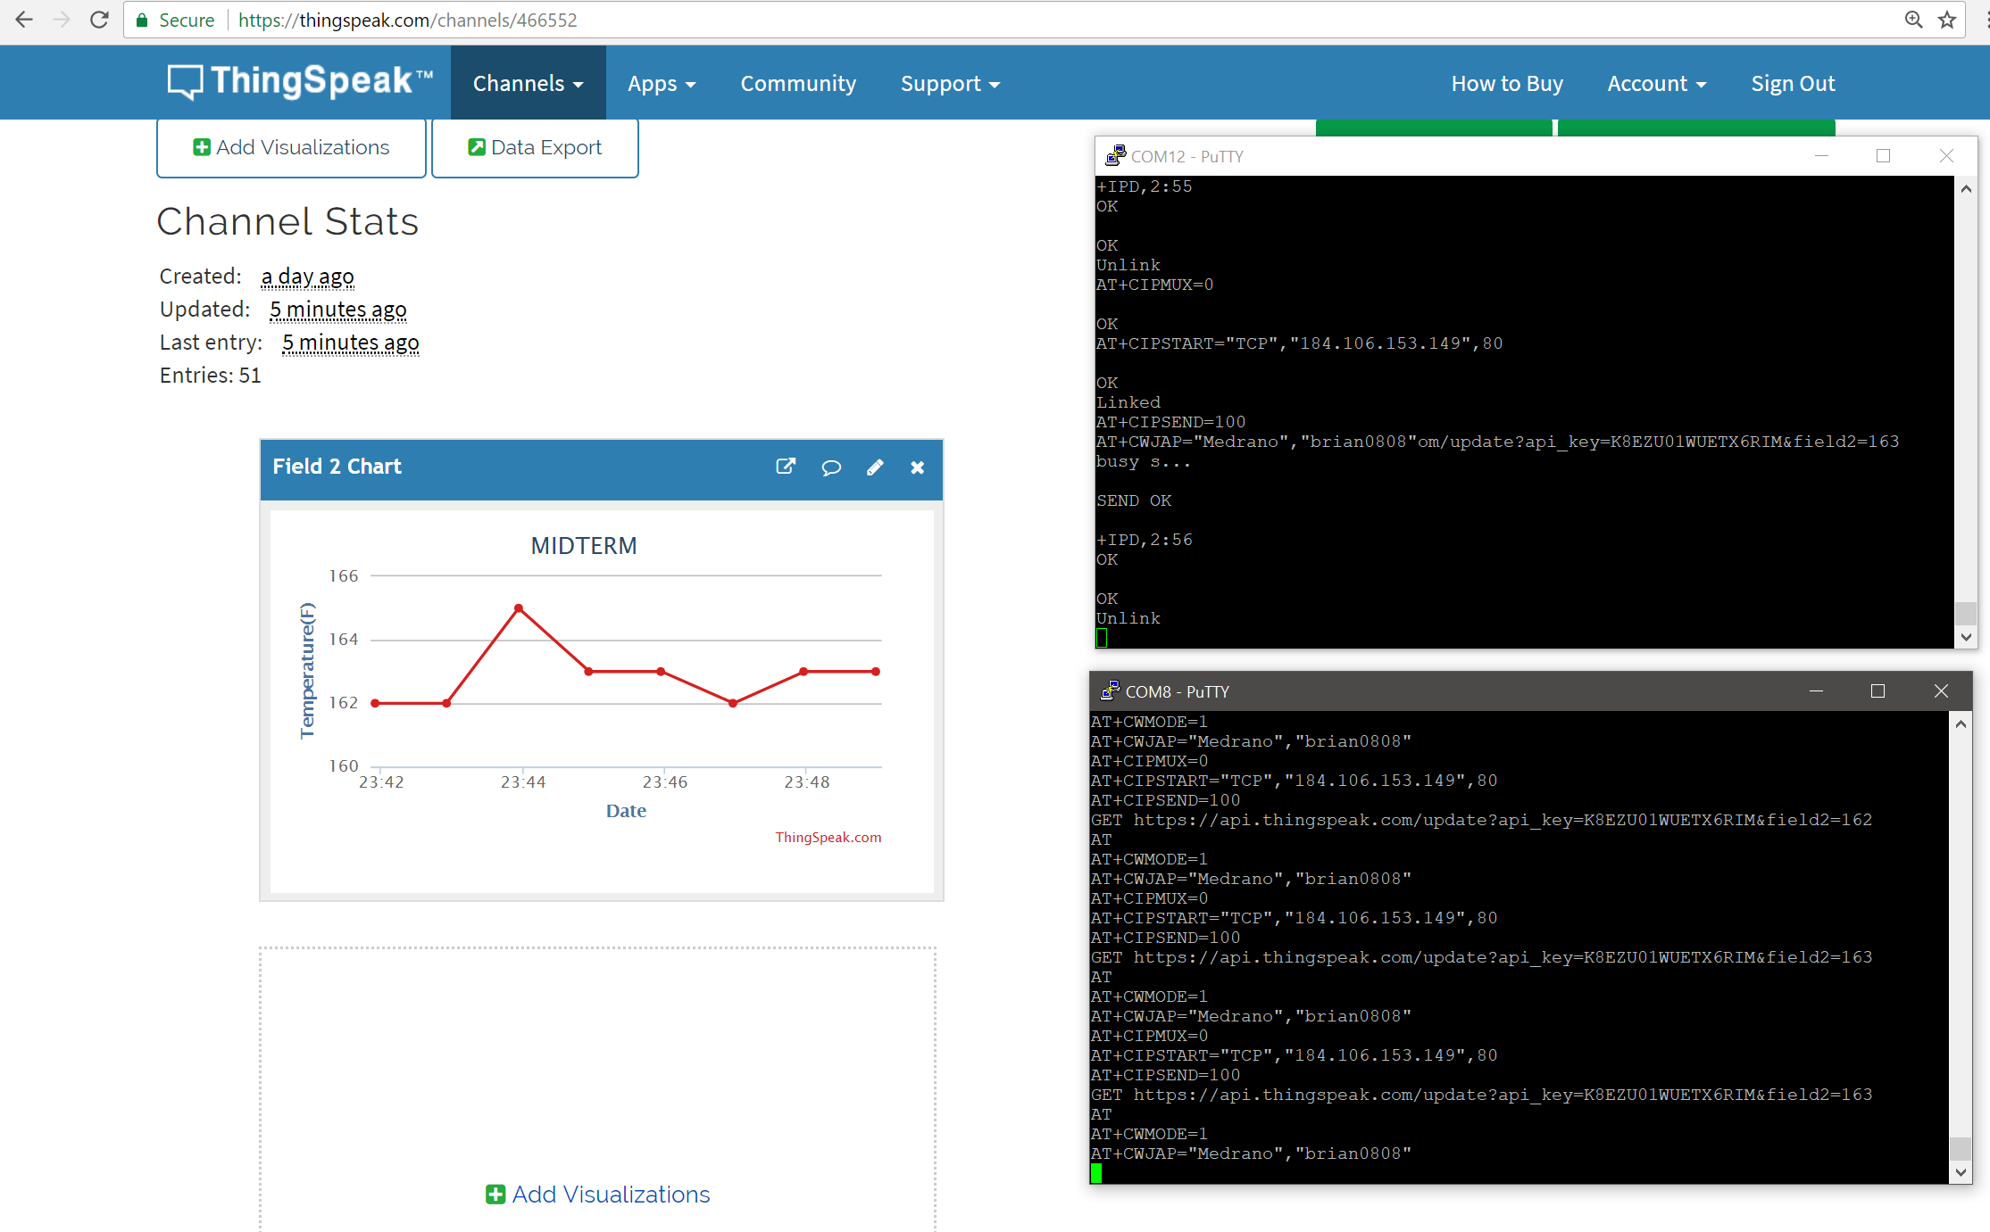

Above is the output of my program on ThingSpeak. The portion where the temperature increases is when I was holding the sensor to make the temperature rise.

The code below is modified and is not inputted with a SSID and Password field.

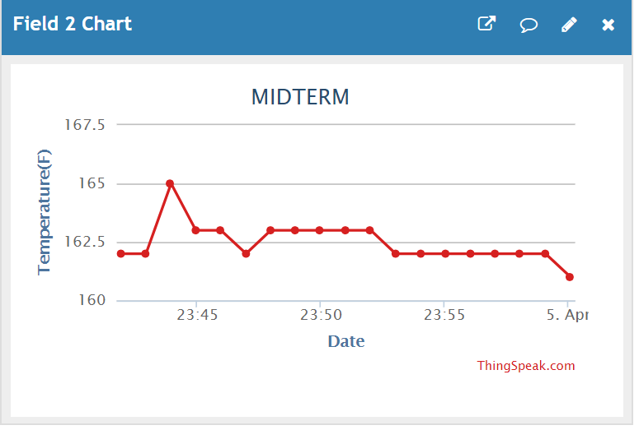

Here is the output in a longer time span to show that the temperature is increasing and decreasing.

1. **ENTIRE CODE**
2. #define *F_CPU* 16000000UL
3. #define BAUD 9600
4. #define MYUBRR *F_CPU*/16/BAUD-1
5. #include <avr/io.h>
6. #include <util/delay.h>
7. #include <stdio.h>
8. #include <avr/interrupt.h>
9. #include <stdlib.h>
10. void read_adc(void); //Read ADC
11. void adc_init(void); //initialize ADC
12. void USART_init( unsigned int ubrr ); //initialize USART
13. void USART_tx_string(char *data); //Print String USART
14. volatile unsigned int adc_temp;
15. char outs[256]; //array
16. //char CWJAP[256];
17. volatile char received_data;
18. void usart_send(unsigned char ascii) //send data to USART
19. {
20. while(!(UCSR0A & (1<<UDRE0 )));
21. UDR0 = ascii;
23. }
24. unsigned char usart_receive(void) //received data
25. {
26. while(!(UCSR0A & (1<< RXC0)));
27. return received_data;
28. }
29. int main(void) {
30. adc_init(); // Initialize the ADC (Analog / Digital Converter)
31. USART_init(MYUBRR); // Initialize the USART (RS232 interface)
32. *_delay_ms*(500); // wait a bit
33. sei(); //interrupt
35. while(1)
36. {
37. }
38. }
39. void adc_init(void) //initialize ADC
40. {
42. ADMUX = (0<<REFS1)| // Reference Selection Bits
43. (1<<REFS0)| // AVcc - external cap at AREF
44. (0<<ADLAR)| // ADC Left Adjust Result
45. (0<<MUX2)| // ANalog Channel Selection Bits
46. (1<<MUX1)| // ADC2 (PC2 PIN25)
47. (0<<MUX0);
48. ADCSRA = (1<<ADEN)| // ADC ENable
49. (0<<ADSC)| // ADC Start Conversion
50. (0<<ADATE)| // ADC Auto Trigger Enable
51. (0<<ADIF)| // ADC Interrupt Flag
52. (0<<ADIE)| // ADC Interrupt Enable
53. (1<<ADPS2)| // ADC Prescaler Select Bits
54. (0<<ADPS1)|
55. (1<<ADPS0);
56. // Timer/Counter1 Interrupt Mask Register
57. TIMSK1 |= (1<<TOIE1); // enable overflow interrupt
58. TCCR1B |= (1<<CS12)|(1<<CS10); // native clock
59. TCNT1 = 49911; //((16MHz/1024)*1)-1 = 15624
60. }
61. void read_adc(void) {
62. unsigned char i =4;
63. adc_temp = 0; //initialize
64. while (i--) {
65. ADCSRA |= (1<<ADSC);
66. while(ADCSRA & (1<<ADSC));
67. adc_temp+= ADC;
68. *_delay_ms*(50);
69. }
70. adc_temp = adc_temp / 4; // Average a few samples
71. }
72. /* INIT USART (RS-232) */
73. void USART_init( unsigned int ubrr ) {
74. UBRR0H = (unsigned char)(ubrr>>8);
75. UBRR0L = (unsigned char)ubrr;
76. UCSR0B |= (1 << TXEN0) | (1 << RXEN0)| ( 1 << RXCIE0); // Enable receiver, transmitter & RX interrupt
77. UCSR0C |= (1<<UCSZ01) | (1 << UCSZ00);
78. }
79. void USART_tx_string( char *data ) {
80. while ((*data != '\0')) {
81. while (!(UCSR0A & (1 <<UDRE0)));
82. UDR0 = *data;
83. data++;
84. }
85. }
86. ISR(TIMER1_OVF_vect) //timer overflow interrupt to delay for 1 second
87. {
88. char TEMP[256];
89. unsigned char AT[] = "AT\r\n"; //AT Commands
90. unsigned char CWMODE[] = "AT+CWMODE=1\r\n"; //Set MODE
91. unsigned char CWJAP[] = "AT+CWJAP=\"SSID\",\"PASSWORD\"\r\n"; //MUST CHANGE WIFI AND PASSWORD
92. unsigned char CIPMUX[] = "AT+CIPMUX=0\r\n";
93. unsigned char CIPSTART[] = "AT+CIPSTART=\"TCP\",\"184.106.153.149\",80\r\n";
94. unsigned char CIPSEND[] = "AT+CIPSEND=100\r\n";
95. *_delay_ms*(200);
96. USART_tx_string(AT); //send commands
98. *_delay_ms*(5000);
99. USART_tx_string(CWMODE); //set mode
101. //snprintf(CWJAP,sizeof(CWJAP),unsigned char CWJAP[] = "AT+CWJAP=\"%s\",\"%s\"\r\n", ssid, passwd;)
102. *_delay_ms*(5000);
103. USART_tx_string(CWJAP); //connect to Wifi
105. *_delay_ms*(15000);
106. USART_tx_string(CIPMUX); //select MUX
108. *_delay_ms*(10000);
109. USART_tx_string(CIPSTART);//connect TCP
111. *_delay_ms*(10000);
112. USART_tx_string(CIPSEND);//send size
114. *_delay_ms*(5000);
116. //snprintf(CWJAP,sizeof(CWJAP),unsigned char CWJAP[] = "AT+CWJAP=\"Medrano\",\"brian0808\"\r\n";)
117. PORTC^=(1<<5);
118. read_adc(); //read ADC
119. *snprintf*(outs,sizeof(outs),"GET https://api.thingspeak.com/update?api_key=K8EZU01WUETX6RIM&field2=%3d\r\n", adc_temp);// print it
120. USART_tx_string(outs);//send data
121. *_delay_ms*(10000);
122. TCNT1 = 49911; //reset
124. }
125. **SCHEMATICS**



1. **BREADBOARD**

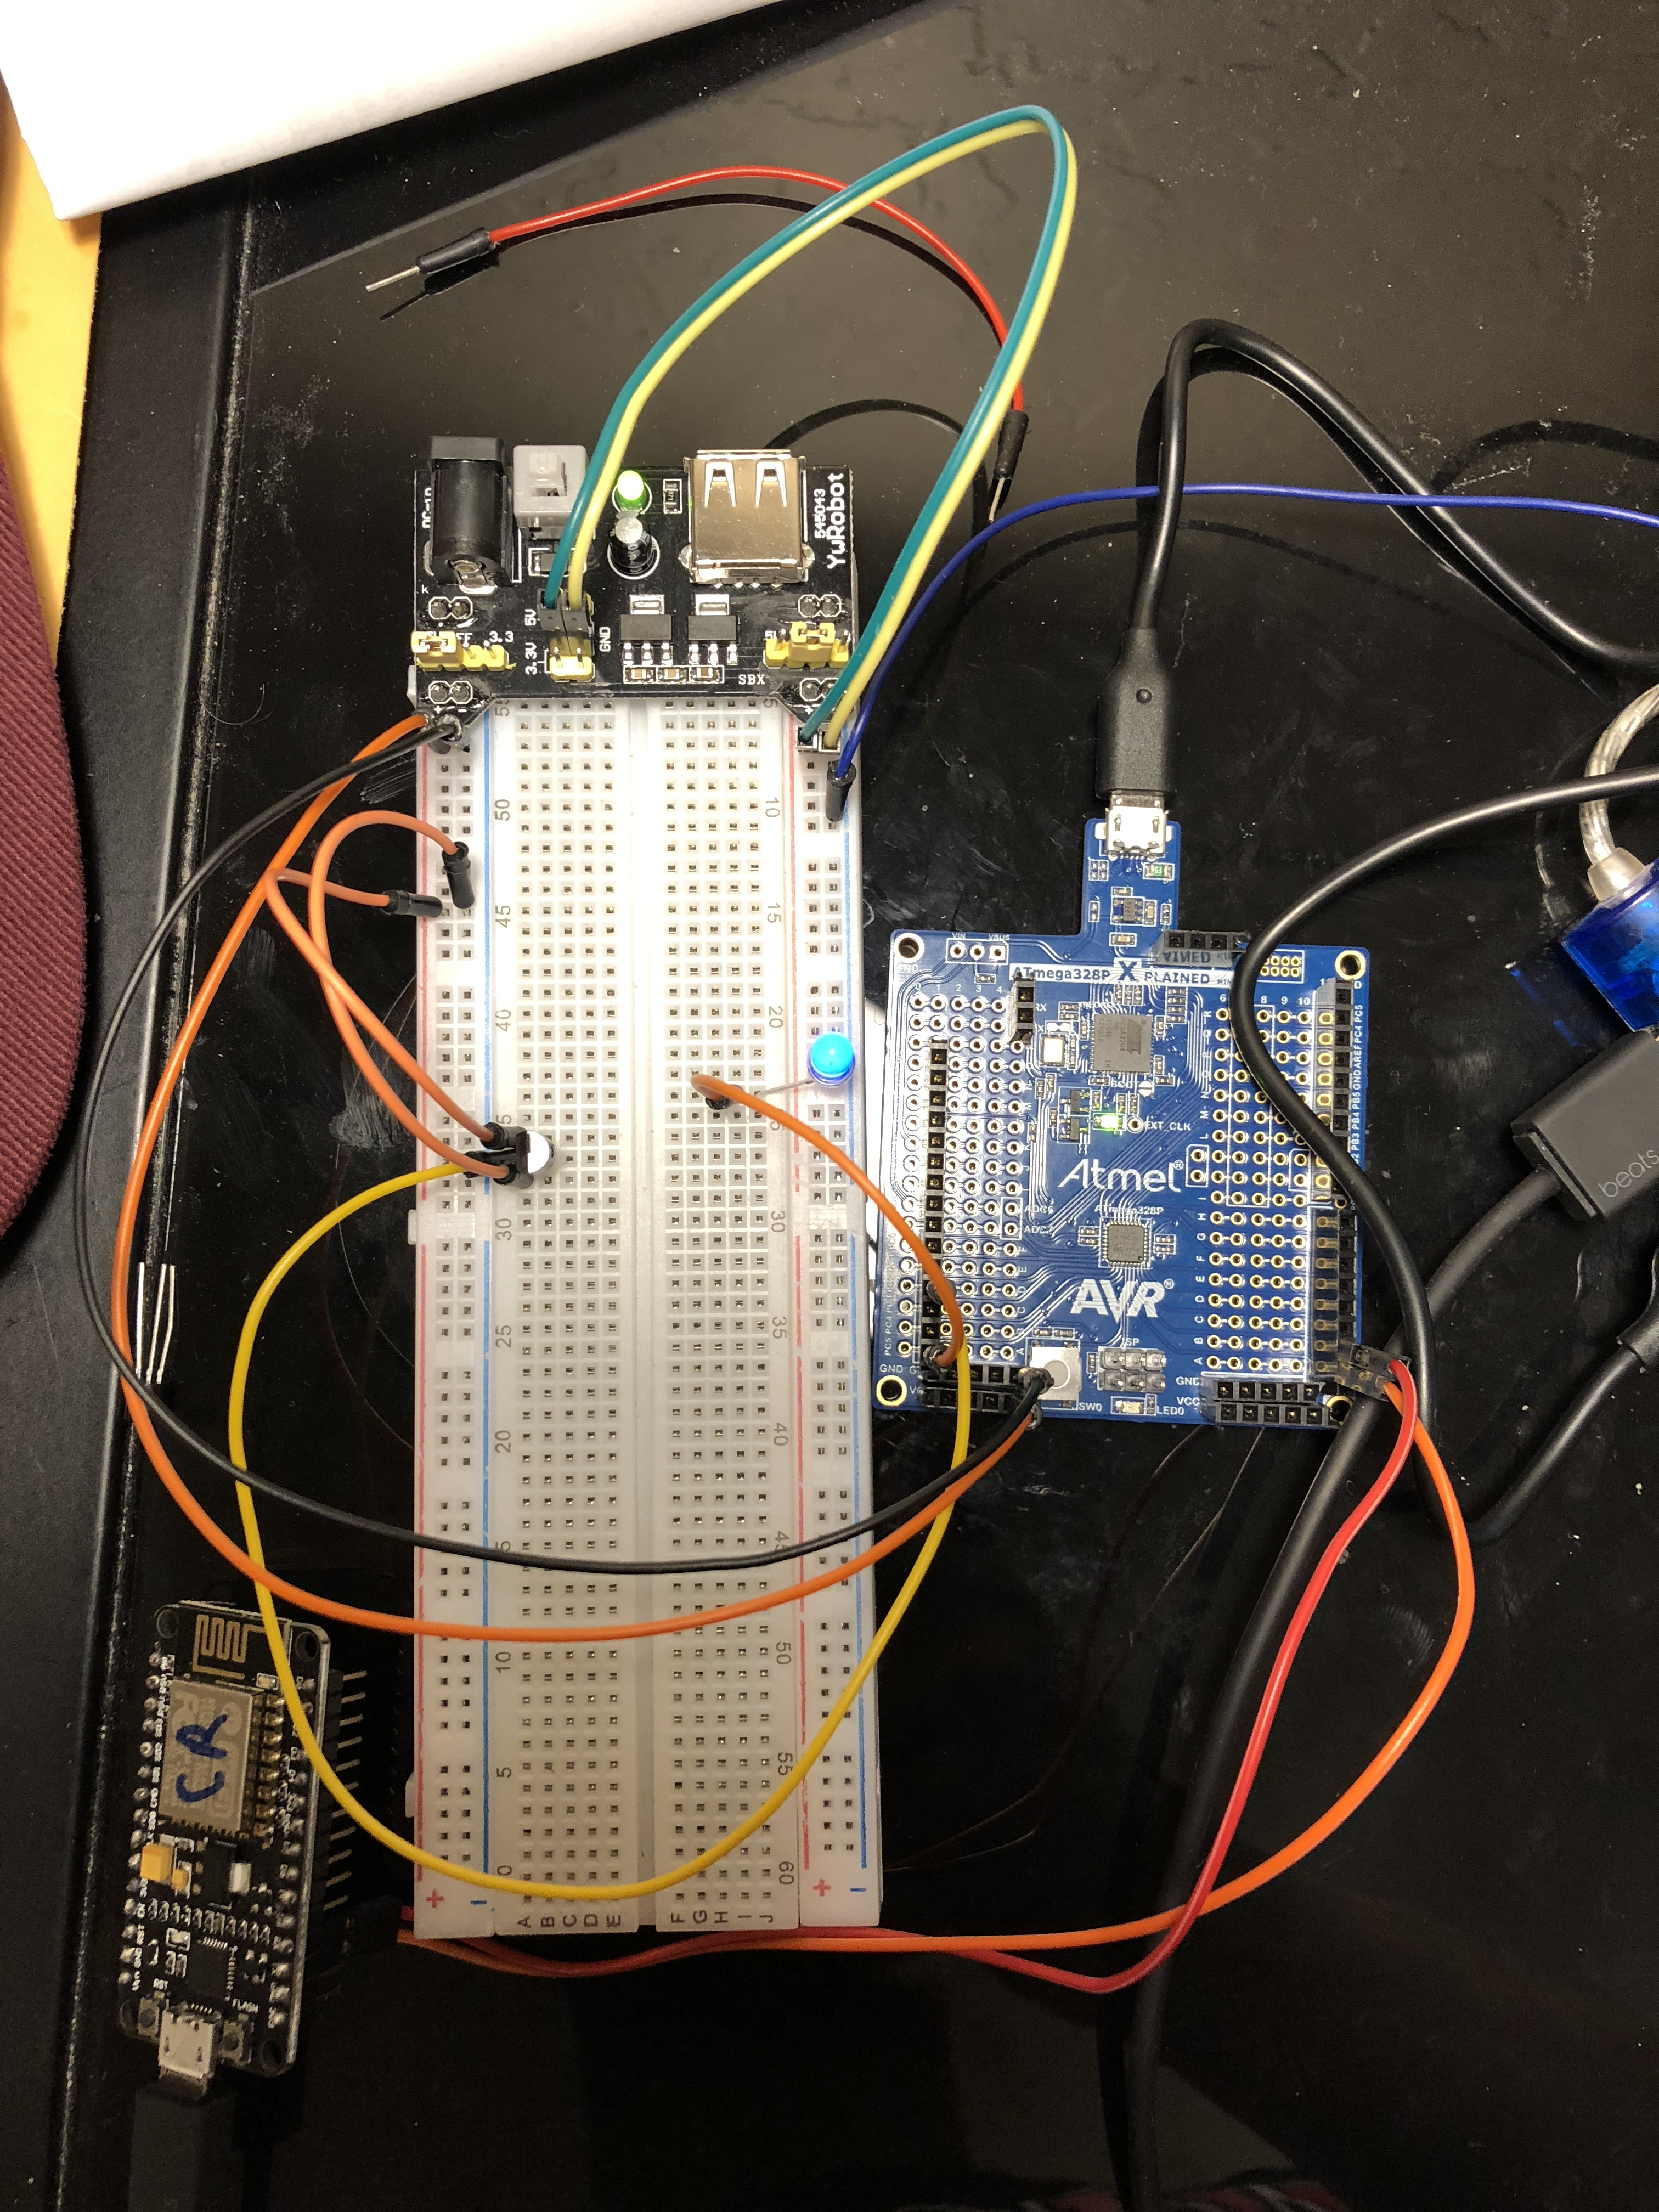

1. **FLOWCHART**

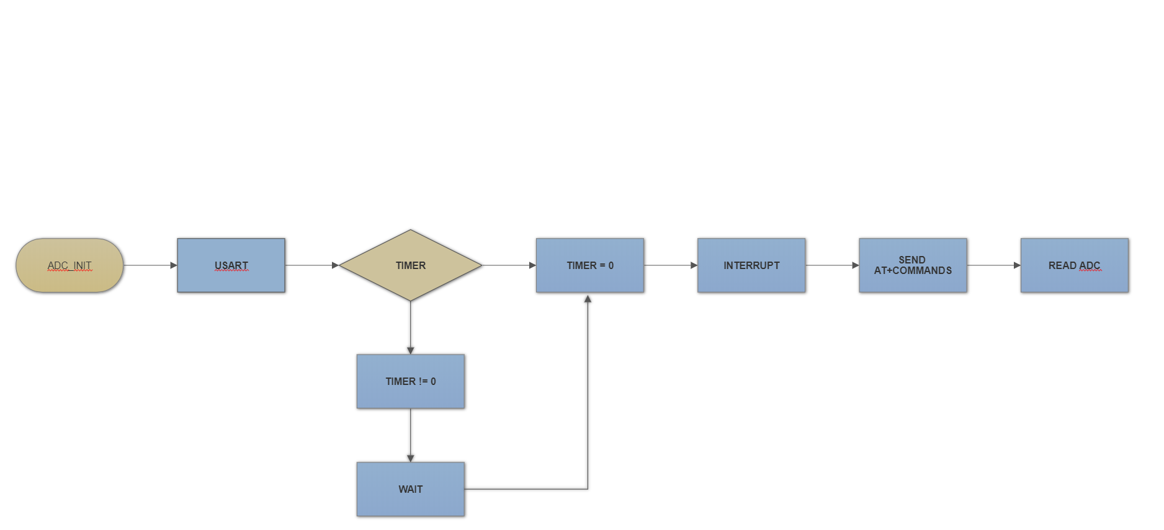

1. **GITHUB LINK**

[**https://github.com/bkiaer/MIDTERM**](https://github.com/bkiaer/MIDTERM)

1. **YOUTUBE LINKS**

<https://youtu.be/risoe-0MmKg> - Video of COM PORT8 (ATMega328P) sending AT+Commands to ESP8266.

<https://www.youtube.com/watch?v=iw3Wa8qSakM> – Video of Thingspeak updating

**Student Academic Misconduct Policy**

<http://studentconduct.unlv.edu/misconduct/policy.html>

“This assignment submission is my own, original work”.

Brian Medrano Kiaer